Crop Prediction ML Project
This project uses ML to predict the best suitable crop according to the soil condition.
Input:
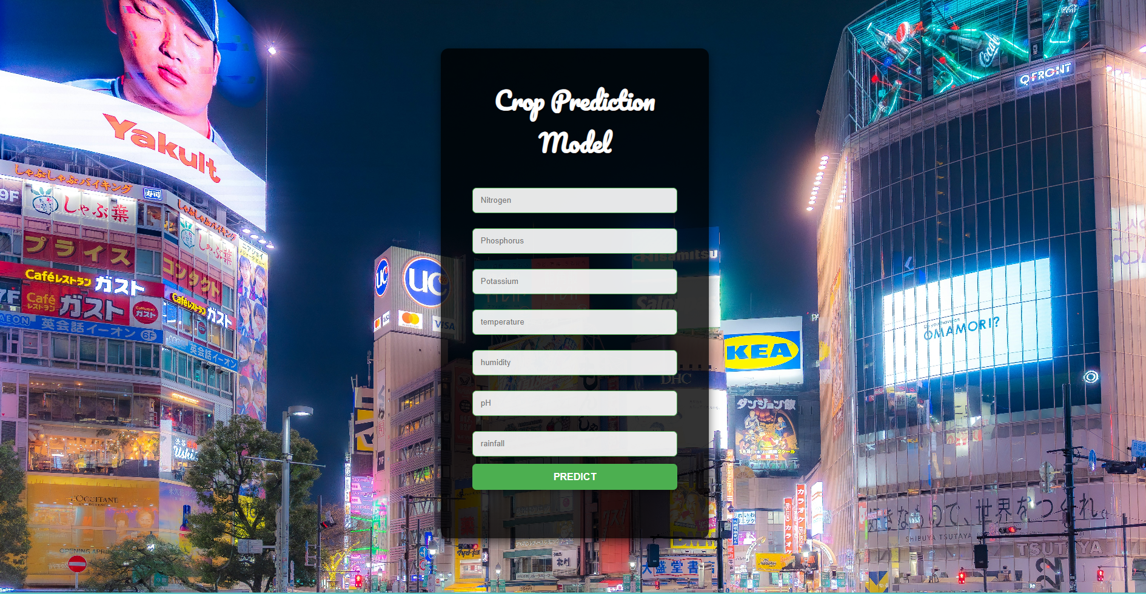

Based on the input project predicts the best suitable crop for the soil condition:

Predicted Crop:


Thanks & Best Regards,
Mayank Tyagi

